- Page 1, line 6: Delete “, as shown in 2”.
- Page 1, line 10: Change “anomalous Doppler effect” to “Anomalous Doppler Effect”.
- Page 1, line 47 and 48: Change “anomalous Doppler resonance” to “Anomalous Doppler Resonance”.
- Page 1, line 61: Change “normal Doppler resonance” to “Normal Doppler Resonance”.
- Page 1, line 64: add “for plane EM wave” after “($m = ±1 ,±2,…)$”.
- Page 2, line 132: Change “normal Doppler effect” to “Normal Doppler Effect”.
- Page 2, line 153 to 155: Change “The kinetic energy along z is T = $γm_{e}c^{2}-m_{e}c^{2}$, where $γ$ denotes the Lorentz factor. The internal energy is expressed as $U=\frac{1}{2}γm_{e}v_{⊥}^{2}$” to “The kinetic energy along z is T = $γm_{0}c^{2}-m_{0}c^{2}$, where $γ$ denotes the Lorentz factor and $m_{0}$ refers to the electron’s rest mass. The internal energy is approximated expressed as $U=\frac{1}{2}γm_{0}v_{⊥}^{2}$”
- Page 2, line 179: Change “$p_{ϕ}=γm_{e}v_{⊥}$” to “$p_{ϕ}=γm_{0}v_{⊥}$”.
- Page 5, line 337: Change “$E_{⊥}=\frac{1}{2}m_{e}v_{⊥}^{2}$” to “$E_{⊥}=\frac{1}{2}m_{0}v_{⊥}^{2}$”
- Page 6, line 355: Change “Eq. 13” to “Eq. 12”.
- Page 6, Fig.6: Change the y label “$E_{∥emw} (eV {10}^{-5})$” to “$E_{emw} (eV {10}^{-5})$” for (c).
Change the legend “Linear-circular polarization” to “Left-circular polarization” for (a),(b) and (c).
Fig 6. should be look like:
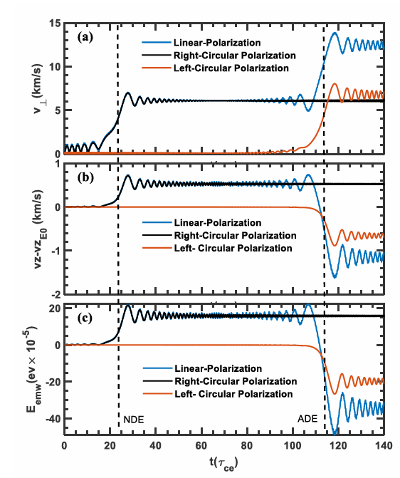
- Page 6, line 385: add “As shown in Fig. 6(c), during the NDE period the electromagnetic wave performs positive work on the electron, an effect analogous to photon absorption. In contrast, during the ADE period the electromagnetic wave performs negative work, indicating that the electron emits photons in a manner similar to stimulated emission.” after “and integrated discretely.”
- Page 7. Fig.A1 : the label “$\frac{{ω-ω}_{ce}}{k}$” should be underneath the shadow region like:
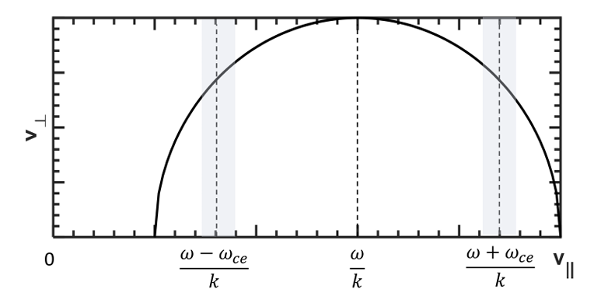
color figures only in the online version.

